**Design and Implementation of Robotic Infusion Stand**

Ahmad Taher Azar1, 2, Hossam Hassan2, Mohd Saiful Akmal Bin Razali2, Gabriel de Brito Silva2,Hedaya Rafat Ali2

1Faculty of Computers and Information, Benha University, Egypt

2Nile University, 6th of October City, Egypt

ahmad_t_azar@ieee.org; [hhassan@nu.edu.eg](mailto:HHassan@nu.edu.eg); [saifulakmal.razali@eu4m.eu](mailto:saifulakmal.razali@eu4m.eu); [gabriel.silva@eu4m.eu](mailto:gabriel.silva@eu4m.eu); hedaya.ali@eu4m.eu

**Abstract.** Infusion Stand is one of the medical supportive tools in the field of biomedical that assist in holding and carrying medications to patients via intravenous injections. Mobilization of Infusion Stand from a place to another place is necessary not only for the patients itself but also for the nurses. Therefore, this leads to not only uneasiness but also inconvenience for both parties. Moreover, the massive size of the Infusion Stand also bring a feeling of irritation as it causes difficulty during maneuvering the Infusion Stand. Therefore, in order to improve the existing situation and current Infusion Stand in the market, we come out with a proposal to design and implement a prototypic Robotic Infusion Stand. This Robotic Infusion Stand comprises two motors with 2 wheels & a caster ball wheels, distance sensor, Arduino Mega as a microcontroller, joystick as an input of the robot and L298N H Bridge driver to control the rotation direction. The novelty of this robotic Infusion Stand is that, it will be moving with an input given on the joystick by the strip reaction and try to follow the person who is in control of the strip. In order to make the robotic Infusion Stand stable, we implemented & fine-tuned a Proportional-Integral-Derivative controller so that it is able to follow the person and to avoid any obstacles.

**Keywords:**

1. Introduction

Infusion Stand is one of the medical supportive tools that not only used extensively in hospitals, clinics, physical practices but also in the supportive care provided in the home [1] [2]. Normally, a conventional Infusion Stand consists of a stand-alone metal structure which includes a rod, a chassis which typically equipped with 3, 4 or 5 legs with and a wheels & a hanger with one or more hooks at the upper part of the Infusion Stand [3]. There are a lot of accessories that will be attached to the Infusion Stand such as bag of fluids like a water, medication & blood, urinary hooks, temporary pacemakers, patient handles & support trays [4].

Research studies from the hospitals, clinics, physical practices and in the supportive care provided in the home found that one of the main drawback of Infusion Stand that currently available in the market is their difficulty to maneuver freely. When a patient want to move away from a confined area, he or she need to drag their own Infusion Stand or in worse case, to get an assistance from the nurse or any other person nearby him or her. Consequently, the nurse will use up his or her time accompanying the patient itself and serving the patient by dragging the Infusion Stand which ends up give inconvenience to the patient and also unproductive day to the nurse itself. Besides, patient and also nurse complaint about the massive size of Infusion Stand that may causes issues while maneuvering the Infusion Stand.

Meanwhile, robotic Infusion Stand is an improved version of existing Infusion Stand whereby it will moving with an input given due to the new elongation of the joystick, which influence by the strip reaction. Research studies from the hospitals, clinics, physical practices and also in the supportive care provided in the home found that one of the main drawback of Infusion Stand that currently available in the market is their difficulty to maneuver freely. When a patient want to move away from a confined area, he or she need to drag their own Infusion Stand or in worse case, to get an assistance from the nurse or any other person nearby him or her. Consequently, the nurse will use up his or her time accompanying the patient itself and serving the patient by dragging the Infusion Stand which ends up give inconvenience to the patient and also unproductive day to the nurse itself. Besides, patient and also nurse complaint about the massive size of Infusion Stand that may causes issues while maneuvering the Infusion Stand.

1. Mathematical model
   1. Kinematic model of a nonholonomic mobile robot

The main feature of the kinematic model of wheeled mobile robots is the presence of nonholonomic constraints due to the rolling without slipping condition between the wheels and the ground [6].

The system-generalized velocities $w$ cannot assume independent values; in particular [7], they must satisfy the constraint entailing that the linear velocity of the wheel center lies in the body plane of the wheel, which is the zero lateral velocity [8]:

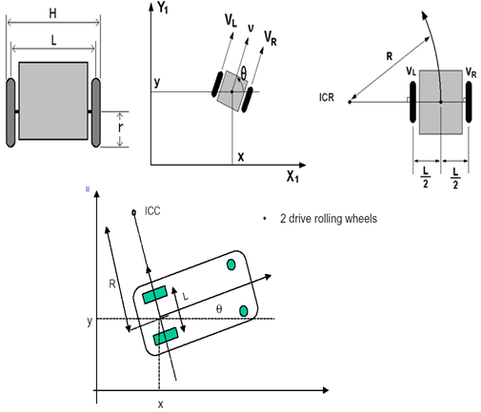

**Fig. 1.** **Kinematic model of a nonholonomic mobile robot**

P= , ()

, y+ ()

**and** ()

The relation between the control input and the speed of wheels these equations is determined:

**and**  ()

**and** ()

()

The system is subject to two nonholonomic constraints, one for each wheel.

()

()

**Table 1.** PHYSICAL PARAMETERS OF NONHLONOMIC ROBOT

|  |  |
| --- | --- |
| $$x$$ | Cartesian coordinate of the front wheel |
| $$y$$ | Cartesian coordinate of the front wheel |
| $$V$$ | Linear velocity |
| $$θ$$ | Orientation of the robot |
| $$w$$ | Angular velocity |
| $$L$$ | the distance between the wheels |
| *r* | Radius of each wheel |
| $$R$$ | Instantaneous curvature radius of the robot trajectory |
| ICC | Instantaneous center of curvature |
| $$v_{R},v_{L}$$ | he linear velocity of the right wheel and left wheel respectively |

()

()

* 1. Mathematical modeling of a DC motor.

A common actuator in control systems is the DC motor [9]. It directly provides rotary motion and, coupled with wheels or drums and cables, can provide translational motion. The electric equivalent circuit of the armature and the free-body diagram of the rotor are shown in the following figure [10].

The torque generated by a DC motor is proportional to the armature current [11] and the strength of the magnetic field. In this case, the magnetic field is assumed to be constant [12] and, therefore, that the motor torque is proportional to only the armature current i by a constant factor $K_{t}$ [13]as shown in the equation below.

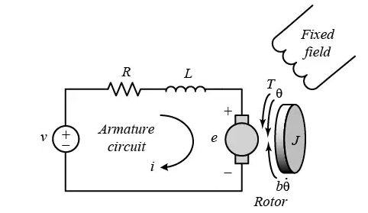

**Fig. 2.** Model representation of a DC motor

**Table 2.** PHYSICAL PARAMETERS OF DC motor

|  |  |
| --- | --- |
| J | Moment of inertia of the rotor (kg.m^2) |
| b | Motor viscous friction constant (N.m.s) |
| $$K_{t}$$ | Electromotive force constant (V/rad/sec) |
| $$K_{e}$$ | Motor torque constant (N.m/Amp) |
| R | Electric resistance (Ohm) |
| L | Electric inductance (H) |
| $$\dot{θ}$$ | angular velocity of the shaft |

()

()

In SI units, Kt = Ke ; therefore, K is used to represent both the motor torque constant and the electromotive force.

()

()

From eq (13) and (14), the Laplace transform is applied and the results are shown by the modeling equations:

()

()

()

1. Controller design

The design target of the system is to control the cart robot with a fuzzy logic algorithm in same time with the arm robot [14]. Therefore, the design task is divided into two parts. The design process is started by the cart robot controller to perform good navigation results.

A typical structure of a fuzzy logic controller is shown in Fig. 8. Using a preprocessor, the inputs that were in the form of crisp values generated from feedback error (e) and change of error (de) [15] were conditioned in terms of multiplying by constant gains before entering into the main control block. The fuzzification block converts input data to degrees of membership functions and matches data with conditions of rules. From the rule based commands, the Mamdani-type inference engine determined the capability of degree of employed rules and returned a fuzzy set for defuzzification block where the fuzzy output data were taken and crisp values were returned.

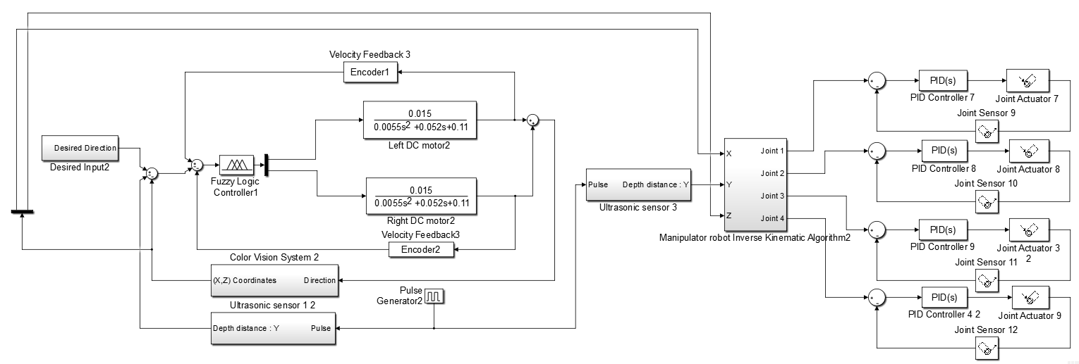

**Fig. 3.** Block diagram of mobile manipulator robot based Fuzzy logic controller

The outputs of the fuzzy sets were converted to crisp values through centroid fuzzification method [16]. The post-processing block then converted these crisp values into standard control signals [17]. In this project, experiential knowledge was borrowed from proportional integral control error and change of error to define fuzzy membership functions. The rule Table 1 was then designed and used with a triangular membership function inputs-output in the fuzzy logic controller and was implemented in the simulation.

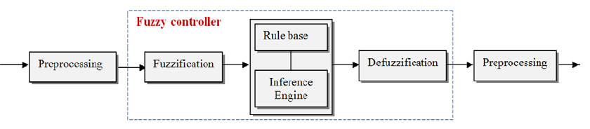

**Fig. 4.** Fuzzy logic controller block diagram



**Fig. 5.** Example of Fuzzy logic output variable, control

These rules make control efforts based on several if-then statements about (e) and (de), i.e., if the error is equal Negative Big (NB) and change of error is equal to negative medium (NM), then the change in control (c) is positive big (PB) [18]. The numbers of these if-then statements were determined based on experiment and tuning of the system. Plots of fuzzy logic membership function *f* the output (c) is shown in Fig. 6.

**Table 3.** Fuzzy logic controller rules table

|  |  |  |  |  |  |  |  |  |  |
| --- | --- | --- | --- | --- | --- | --- | --- | --- | --- |
| De/e | NVB | NB | NM | NS | Z | PS | PM | PB | PVB |
| NVB | PVB | PVB | PVB | PB | PM | PM | PS | Z | Z |
| NB | PVB | PVB | PB | PM | PS | PS | PS | Z | Z |
| NM | PVB | PB | PM | PS | PS | Z | Z | Z | NS |
| NS | PB | PM | PM | PS | PS | Z | Z | NS | NS |
| Z | PM | PM | PS | Z | Z | Z | NS | NS | NM |
| PS | PM | PS | PS | Z | NS | NS | NM | NM | NB |
| PM | PS | PS | Z | NS | NS | NM | NB | NB | NB |
| PB | PS | Z | Z | NS | NM | NM | NB | NVB | NVB |
| PVB | Z | Z | NS | NM | NM | NB | NB | NVB | NVB |

1. Results and discussion
   1. Cart robot controller’s results

The performances of the fuzzy logic controller are simulated in MATLAB© and also implemented in real mobile manipulator robot. A signal generator produces input references for each control blocks. The fuzzy logic controller block processes the inputs, output of fuzzy inference engine, and generate control signal to control the DC motor dynamic model. The behavior of the closed loop response and the performance of the controllers were evaluated by input step functions with results plotted in Fig 6 and 7.

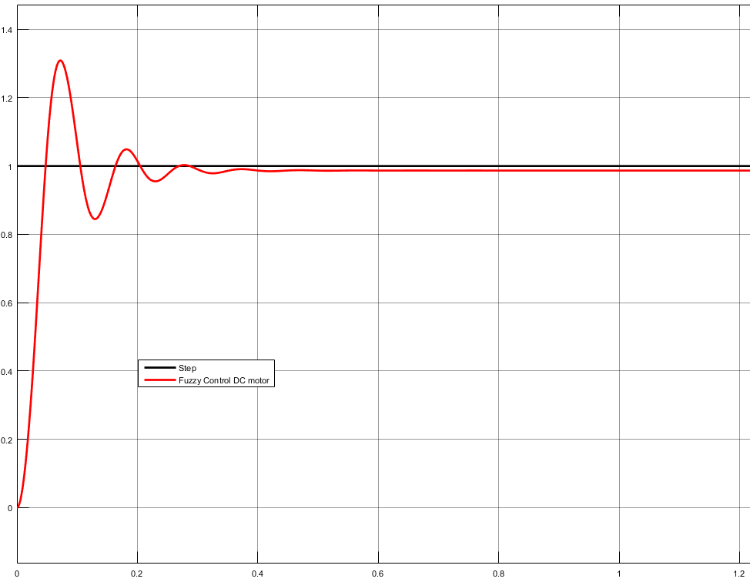

**Fig. 6.** Step response of the Fuzzy logic controller

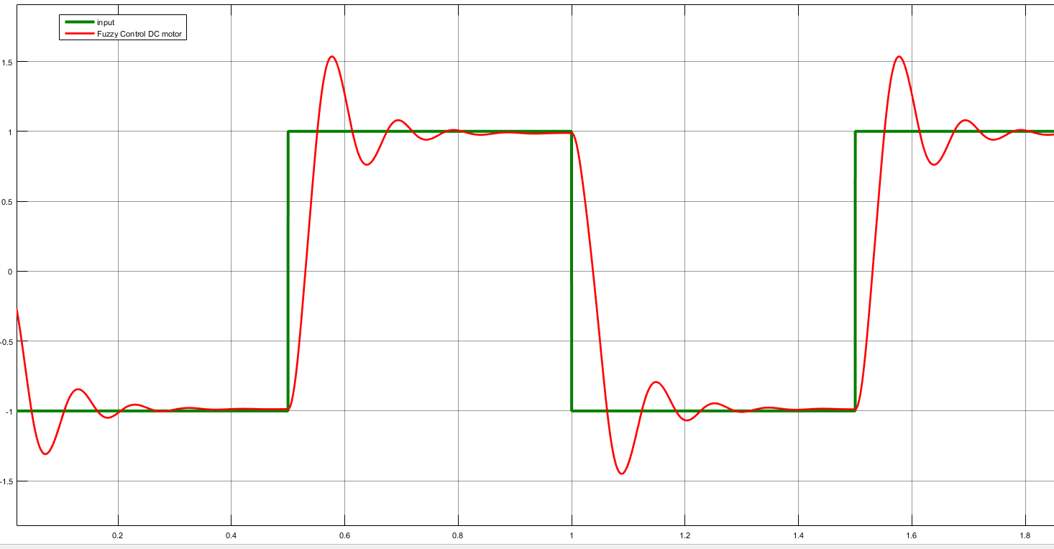

**Fig. 7.** Fast change input response of the Fuzzy controller

The above simulations show that the fuzzy controller can satisfactorily control a variety of processes. It yields a good control performance, which is confirmed by comparing performances indexes such as the percent maximum overshoot, settling time, and the stability**.**  The Fuzzy logic controller is quietly faster however, it has a problem of maximum overshoot, which exceeds 27%. In addition, it has a permanent steady state error as shown in fig.6.

1. Conclusion

The mobile manipulator platform requires precise autonomous devices to perform labor-intensive task such as data collections and image acquisition. This study discussed about simulation and analysis of the fuzzy design for speed control of a DC motor actuator that was used in a mobile robot platform, which moves between crop rows to collect image data and to track an object due to its color. A linear differential equation describing the electromechanical properties of a DC motor to model the relation between voltage input and shaft rotation output was first developed using basic laws of physic. This transfer function was then used to analyze the performance of the system and to design proper controllers to meet the design criteria. To achieve smoother control, a fuzzy logic controller with two inputs and one output including was designed. The results showed that for rectangular changes of the robot speed, the fuzzy logic controller has a good performance in terms of rise time.

References

1. Jost G, Tseng CC (1990) Baxter International Inc., assignee. Home care intravenous stand. United States Patent US 4,905,944.
2. Larson GR (1980) Larson Godfrey R, assignee. Handle for mobile intravenous stand. United States Patent US 4,225,104.
3. Pryor JW (1982) Pryor John W, assignee. Ambulatory patient support stand. United States Patent US 4,332,378.
4. Vignali M (2006) Intravenous Stand Design. Project partners from Huazhong University of Science and Technology, China.